Payeer for CMS Prestashop 1.6

Go to admin panel and navigate to «Modules and Services -> Modules and Services».
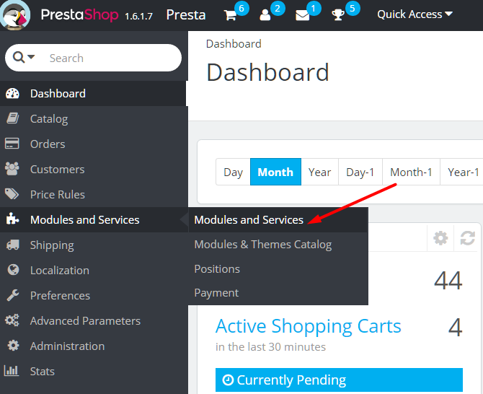

Click «Add a new module».
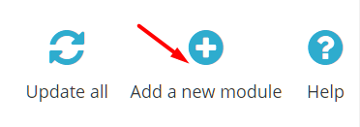

Select the file payeer.zip and click "Upload this module".
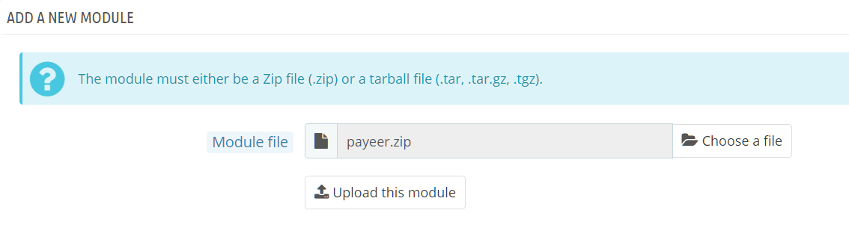

In the list of modules, open the category “Payments and Gateways”.
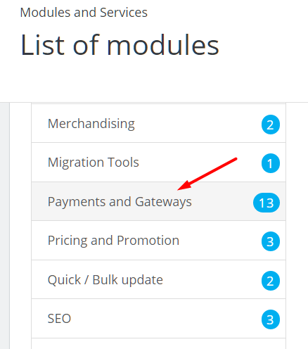

In the list of payment system find Payeer and click install.
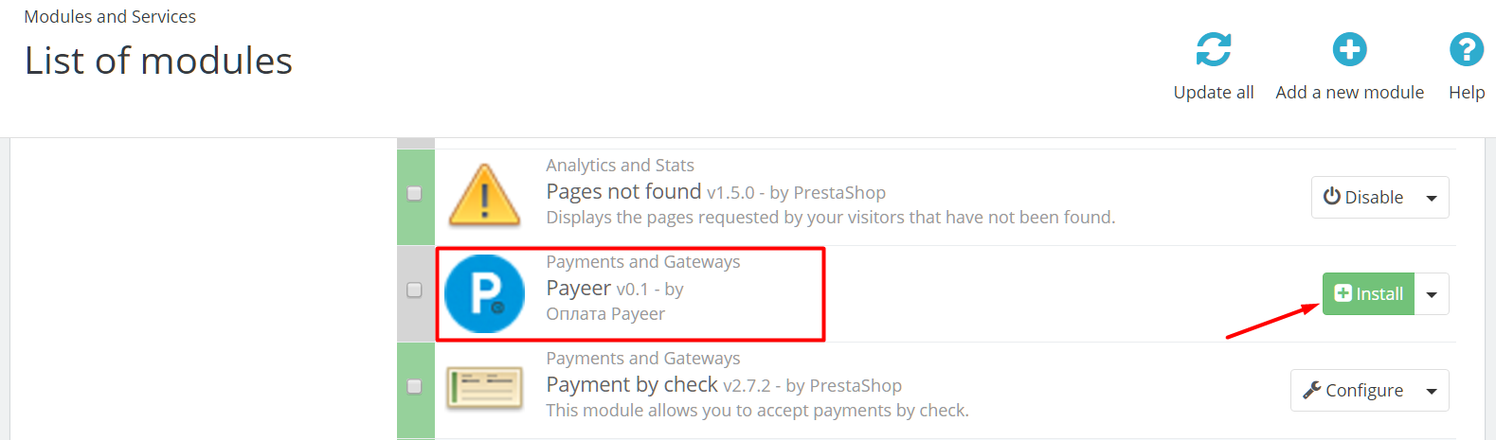

In the next window will display information about that module is not checked PrestaShop. Click “Proceed with the installation”.
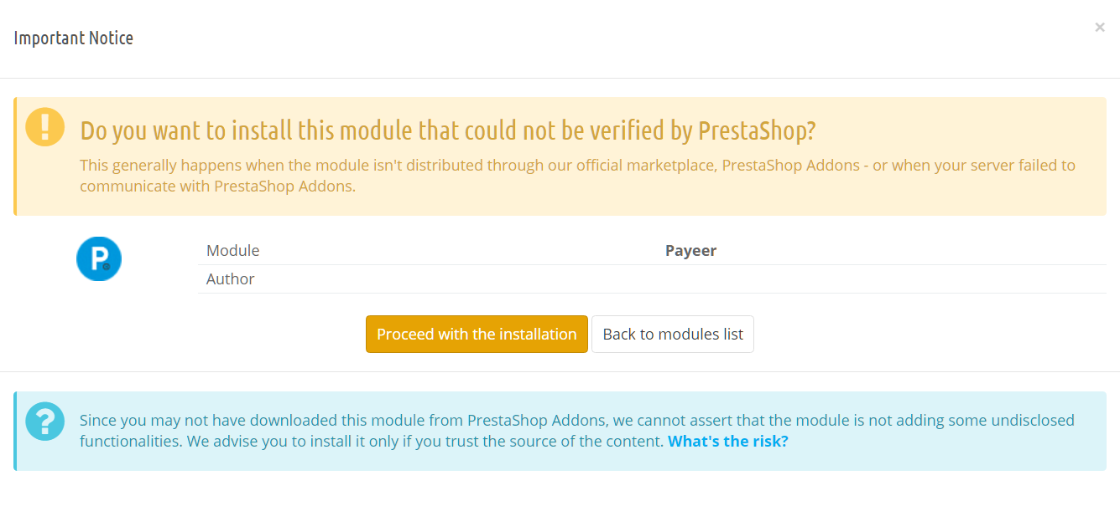
After installation, enter the system settings in the settings Payeer.
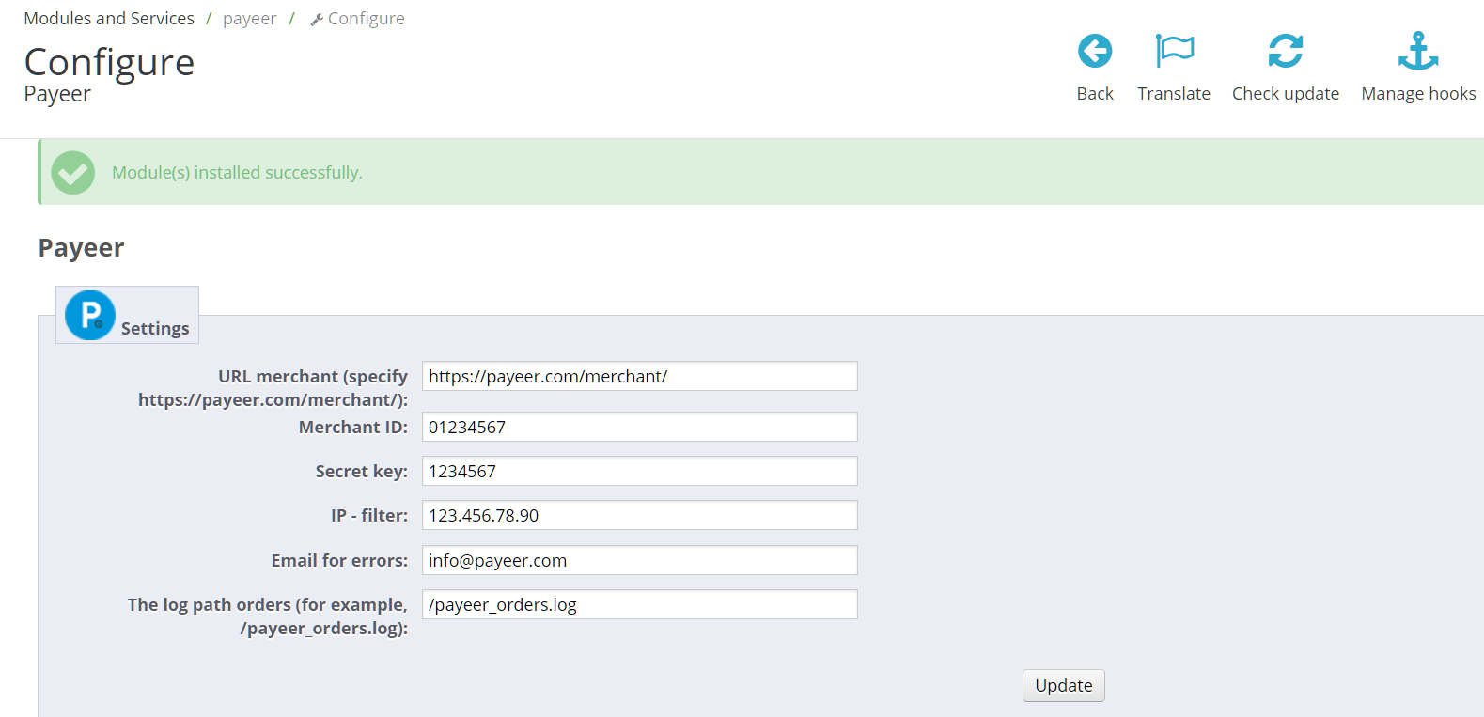

Be sure to fill in:
URL merchant — by default, the path to payment https://payeer.com/merchant/
Merchant ID — id of your store in the system Payeer.com (you can find in personal account)
Secret key – the secret key of your shop
IP–filter — You can specify the list of all trusted ip addresses of servers, separated by commas. You can also specify a mask instead of the ip address. If the field is empty, checking for trusted ip addresses not performed.
For example:
192.168.71.87, 192.165.83.17, 192.178.34.15
Or 192.*.71.87, 192.165.83.*, 192.*.34.15
Or *.*.*.* - all available ip addresses

Email for errors – Enter an email address to which to send notifications in the case of payment errors. The letter will state the reason for and basic information about the payment.
If you specify the path to the file log, it will be recording information about payments through Payeer.
To save the settings, click "Update".

Then, enter the URL in “Dashboard Payeer → Merchant → Settings”
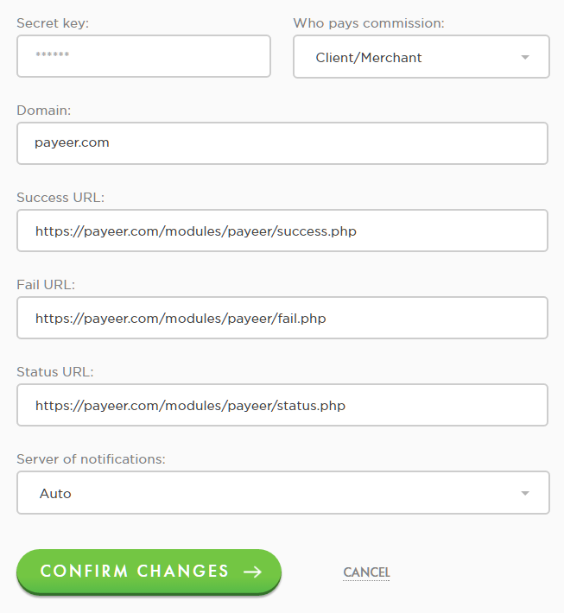

Success URL
http:// *****/modules/payeer/success.php
Fail URL
http:// *****/modules/payeer/fail.php
Status URL
http:// *****/modules/payeer/status.php
Where ***** is your domain

Click “Confirm changes”.
Payeer module for CMS Prestashop 1.6 is configured.

